**Technical Documentation – PENC MiddleWare – Deploy Digital Services Config Files**

1. Workflow – Deploys Digital Services Configuration files to Digital Services Servers. The workflow can be modified to migrate files to any location on any Pensions Linux server



1. Survey – User Supplied Variables

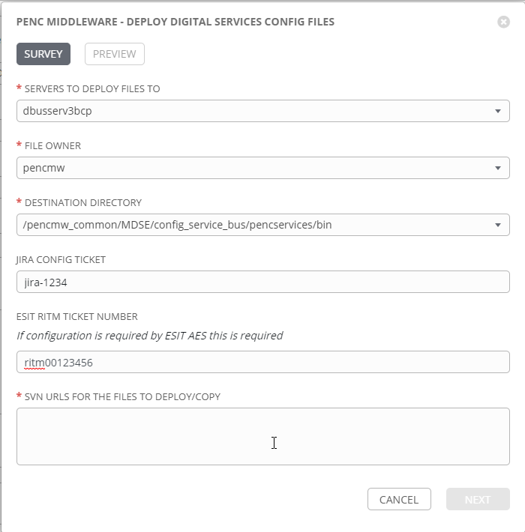

| **Survey Extra Variables** | **Prompt** | **Type** | **Description and Usage** |
| --- | --- | --- | --- |
| destination_hosts | Servers To Deploy Files To | Multiple Choice Single Pick | This is a drop down list of current digital services hosts. It can be modified for any number of hosts if required. Current Drop Down List:  dbusserv3bcp  dbusserv4bcp  dbusserv3bcp, dbusserv4bcp  tbusserv3bcp  tbusserv4bcp  tbusserv3bcp, tbusserv4bcp  mbusserv3bcp  mbusserv4bcp  mbusserv3bcp, mbusserv4bcp  pbusserv3bcp  pbusserv4bcp  pbusserv3bcp, pbusserv4bcp |
| file_owner | File Owner | Multiple Choice Single Pick | Linux user that will own the files deployed. This can be modified to add directories if required. Current Drop Down List:  pencmw  oracle |
| Destination_Directory | Destination Directory | Multiple Choice Single Pick | Linux directory to copy the files to. This can be modified to add directories if required, Current Drop Down List:  /pencmw/pencservices/config  /pencmw/pencservices/bin  /pencmw_common/MDSE/config_service_bus/pencservices/config  /pencmw_common/MDSE/config_service_bus/pencservices/bin  **Note:** If you add the files to any of the sub-directories off of /pencmw_common the files only need to be copied ONCE on a single node as that mount point is common across all of the servers. |
| JiraNumber | JIRA Config Ticket | Text | Optional freeform text area – If it is populated the send_notice_to_aes job includes the JiraNumber in the email notification. |
| RitmNumber | ESIT RITM Ticket Number | Text | Optional freeform text area – If it is populated the send_notice_to_aes job includes the RitmNumber in the email notification. As well the deploy files job copies the FileArtifacts to the Destination_Directory with an Extension of RitmNumber. This allows any changes the RITM Ticket includes to be applied by AES prior to putting the file in place. |
| FileArtifacts | SVN URLS For the Files To Deploy/Copy | Text Area (20K) | Required Text Area with the SVN URLS (one line per artifact) of the format:  http://owl.penc.local:18080/svn/repo/artifact_name, username, revision_number.  SVN Urls are typically around 150 characters, so over 100 artifacts could potentially be deployed at once.  i.e:  http://owl.penc.local:18080/svn/deploy_automation/trunk/Ansible_PlayBooks/BIP/deploy_bip_artifacts_new.yml, mikcharc, 1047 |

1. Jobs Used by the workflow - http://owl.penc.local:18080/svn/deploy_automation/trunk/Ansible_PlayBooks/Utilities

| **Job Template** | **Ansible Playbook** | **Credentials / host** | **Project** | **Description and Usage** |
| --- | --- | --- | --- | --- |
| create_file_copy_vars | create_file_copy_vars.yml | None – runs on localhost as awx linux user | Utilities | Creates Variables/Artifacts for use within the workflows, based on the User supplied survey results.  Artifacts Defined with examples  StageDir: /codemove_common/dp_automation/stage/file_copy  date_time: '20201204_092625'  stage_server: diagoras1bcp  tower_hostname: pdeploy1bcp.penc.local |
| stage_file_artifacts | stage_file_artifacts.yml | Codemove for {{stage_server}} – diagoras1bcp  pendeploy_svn – used to extract artifacts using the svn urls supplied. | Utilities | Stages File Artifacts from a SubVersion repository to the {{StageDir}}/{{date_time}} directory on the {{desination_hosts}}. |
| deploy_files | deploy_files.yml | {{file_owner}} on {{destination_hosts}} | Utilities | Copies files from {{StageDir}}/{{date_time}} directory to the {{Destination_Directory}} using the Ansible ‘copy’ module. If the file already exists it creates a backup of the file. If {{RitmNumber}} is defined it will copy the file artifact with an extension of {{RitmNumber}}. This allows AES to modify the file based on the associated ritm ticket |
| send_notice_to_aes | send_notice_to_aes.yml | None – runs on localhost as awx linux user | Utilities | Sends a notice to mail addresses in {{aes_mail_list}} that the {{FileArtifacts}} were copied to directory {{Destination_Directory}} on {{destination_hosts}} |

1. Workflow Extra Vars – Defined at the Workflow Level

|  |  |  |
| --- | --- | --- |
| **Extra Variable** | **Example Values** | **Description and Usage** |
| aes_mail_list | ---  aes_mail_list:  - Mike.Charchuk@pensionsbc.ca  - jamie.gibbon@pensionsbc.ca | This variable is used within the send_notice_to_aes job/playbook as the ‘to:’ list for the Ansible mail module that notifies staff that the files have been copied/deployed to the host(s). It MUST be populated with a valid email address as the job ALWAYS sends an email.  If you wish to notify AES directly from the workflow add their email address into this field prior to running the job. |